Polygon–Circular Mixed Shapes
# Source: AI Source: Provided by: [Data Path: Persons Table -> ID Column: 1, Name_En Column: Motasem Essam] -> From: [ChatGPT] on [7/25/2026]
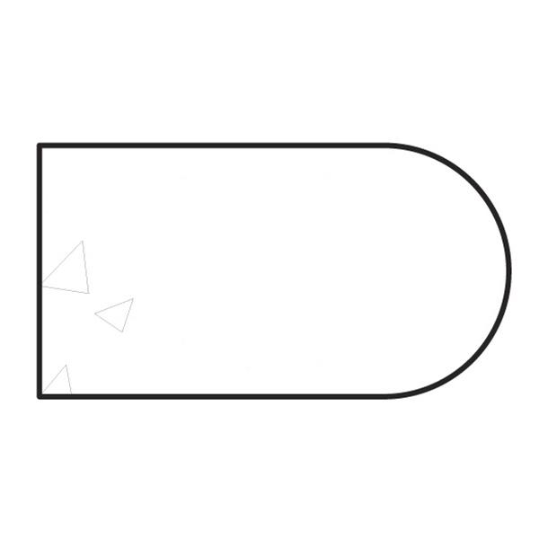
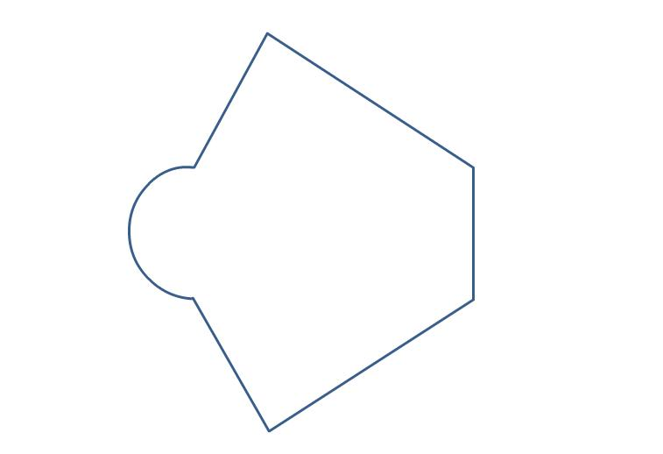
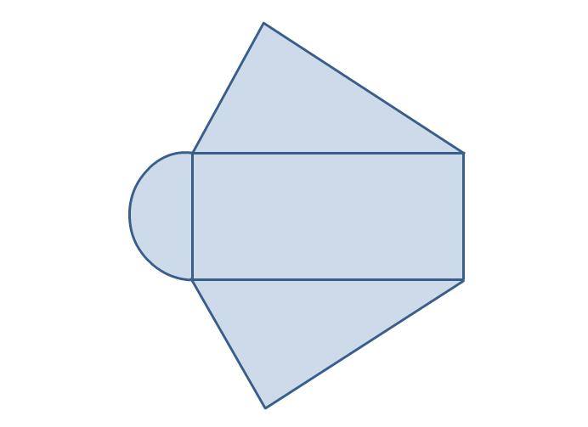
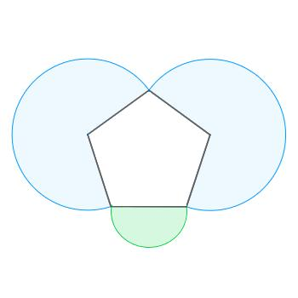

Definition
# Source: AI Source: Provided by: [Data Path: Persons Table -> ID Column: 1, Name_En Column: Motasem Essam] -> From: [ChatGPT] on [7/25/2026]
A Polygon–Circular Mixed Shape is an irregular mixed shape composed of both polygonal elements (straight-line segments) and circular or circular-arc elements (curved boundaries).
In simple terms:
It is a shape that combines straight polygonal boundaries with circular curved boundaries.
$$\boxed{\text{Polygon–Circular Mixed Shape}=\text{Polygonal Elements}+\text{Circular Elements}}$$

Characteristics
# Source: AI Source: Provided by: [Data Path: Persons Table -> ID Column: 1, Name_En Column: Motasem Essam] -> From: [ChatGPT] on [7/25/2026]
A polygon–circular mixed shape typically:
- Is a closed shape when its complete boundary forms a loop.
- Contains at least one straight boundary.
- Contains at least one circular arc or circular boundary.
- Is generally irregular when the straight and curved components do not form a standard regular figure.
- Can contain several polygonal and circular components.
- Can be decomposed into simpler geometric shapes for measurement.

Common Types

1. Polygon + Semicircle
# Source: AI Source: Provided by: [Data Path: Persons Table -> ID Column: 1, Name_En Column: Motasem Essam] -> From: [ChatGPT] on [7/25/2026]
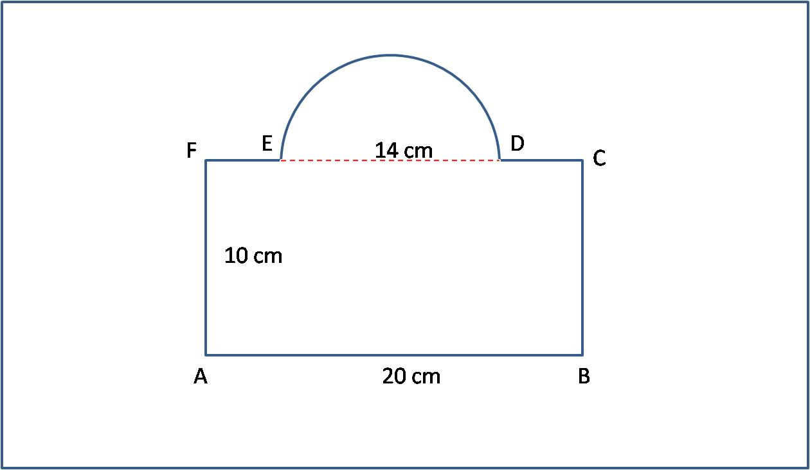
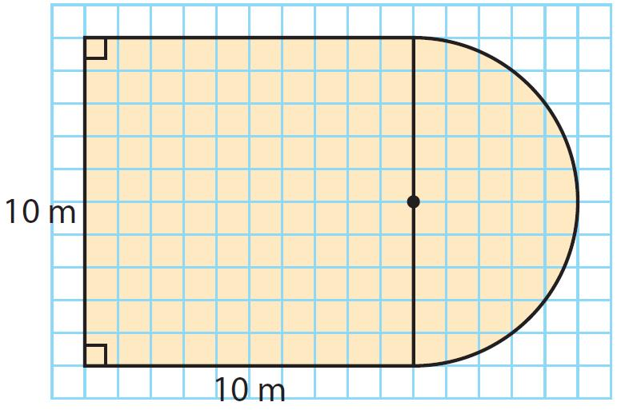
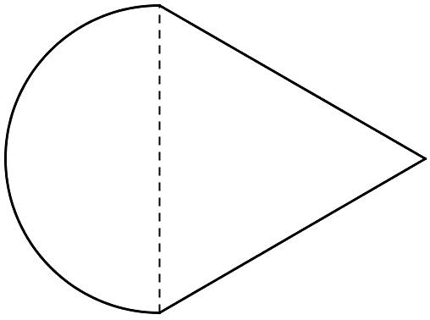
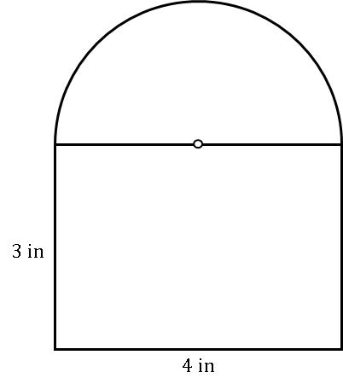

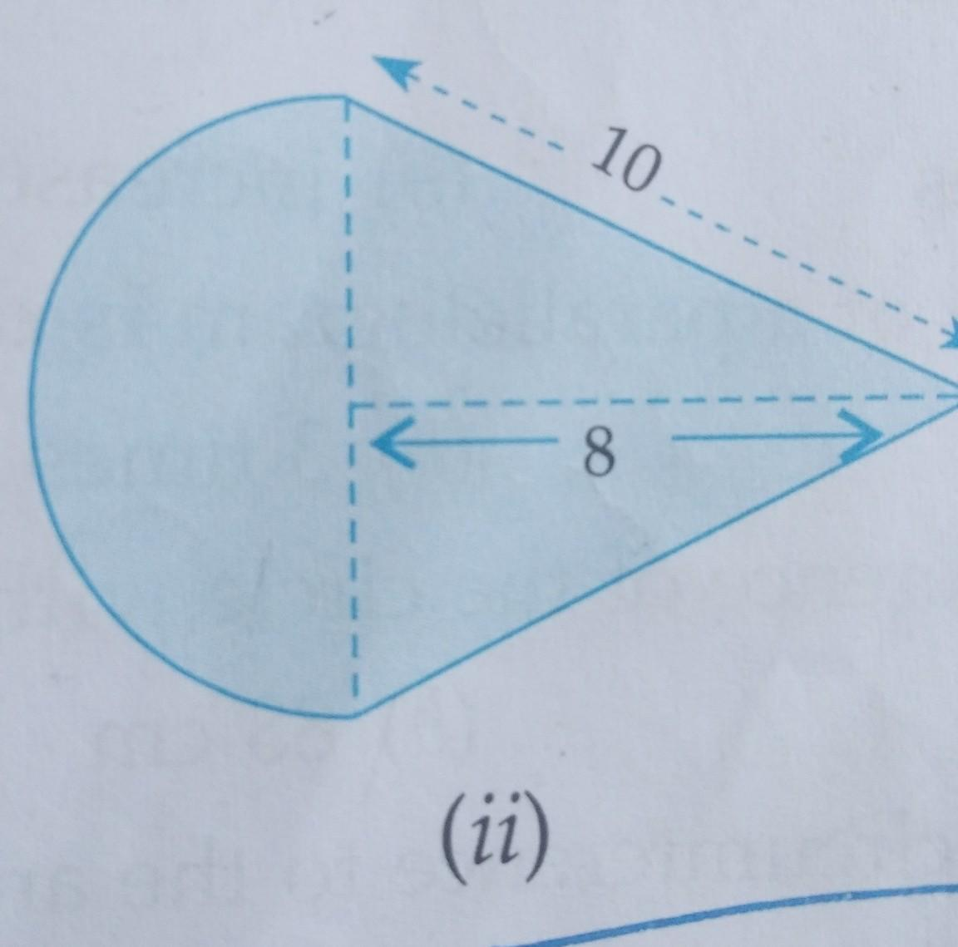
A polygon is combined with a semicircular boundary.
Example: rectangle + semicircle.

2. Polygon + Quarter Circle
# Source: AI Source: Provided by: [Data Path: Persons Table -> ID Column: 1, Name_En Column: Motasem Essam] -> From: [ChatGPT] on [7/25/2026]
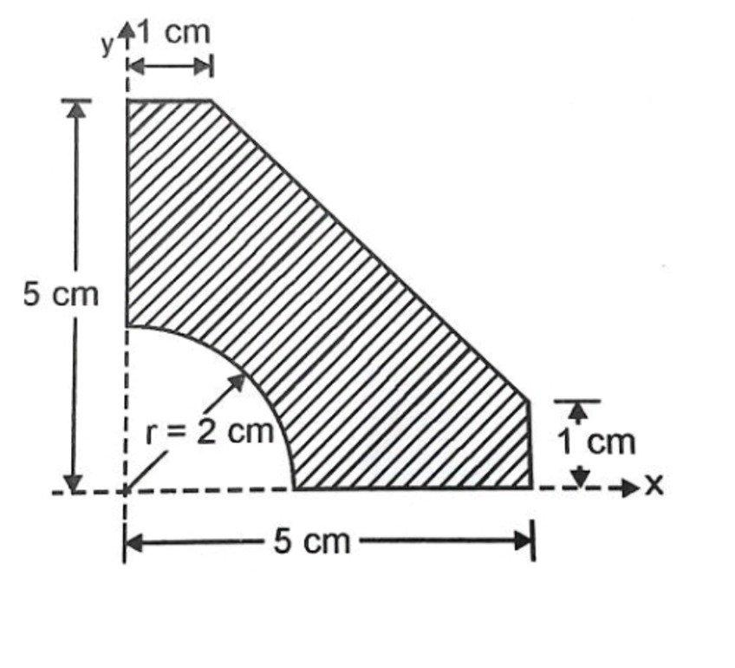
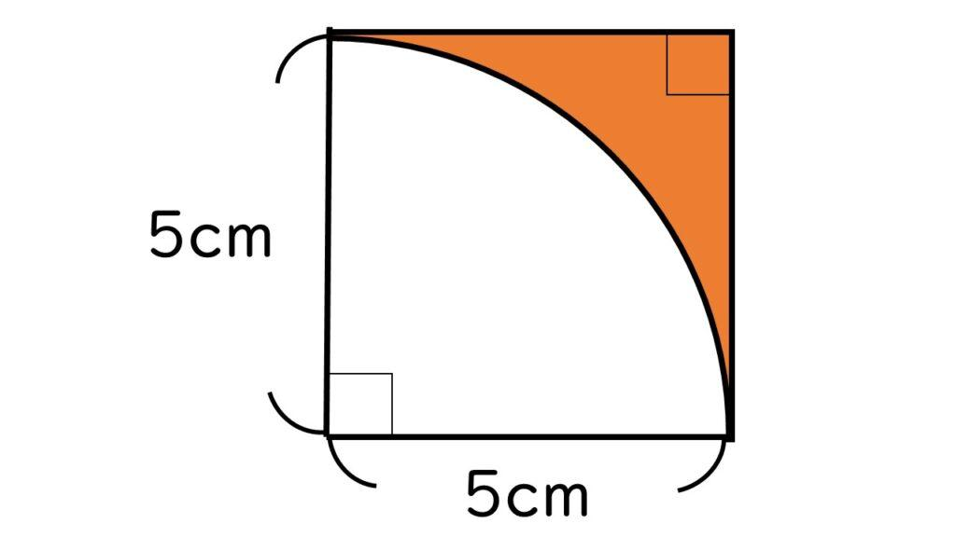
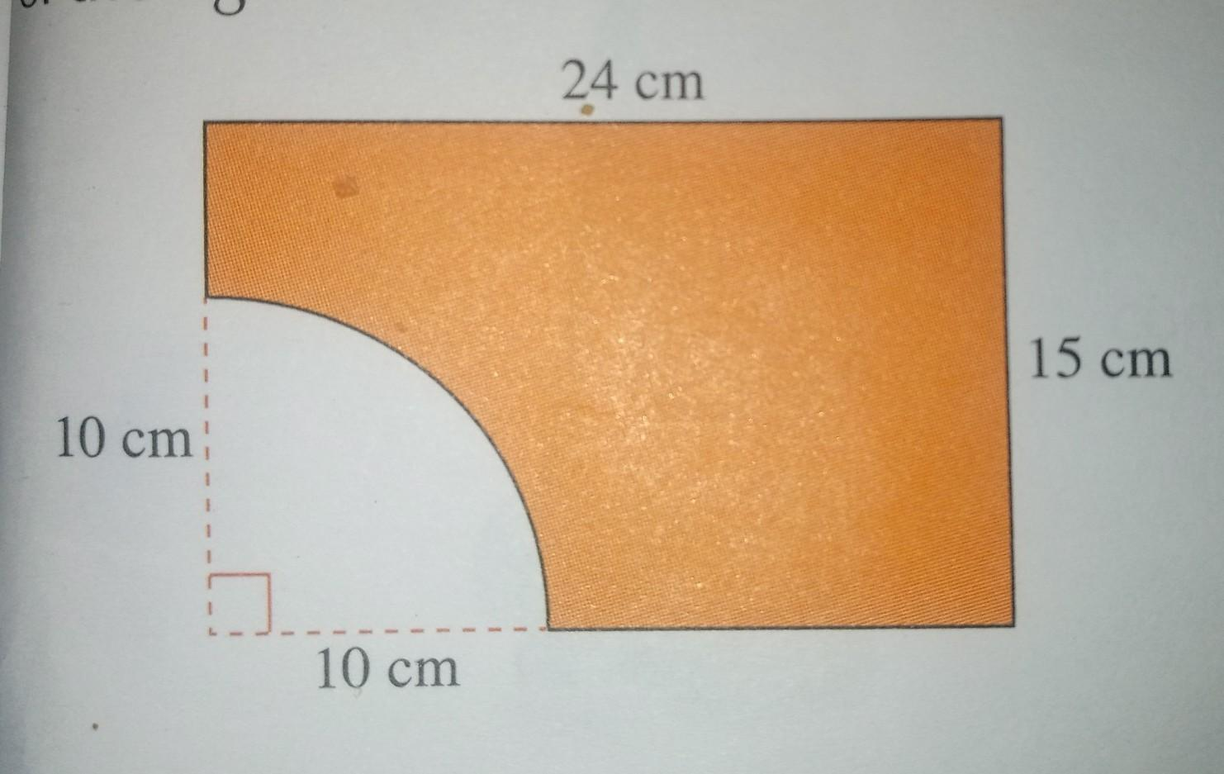
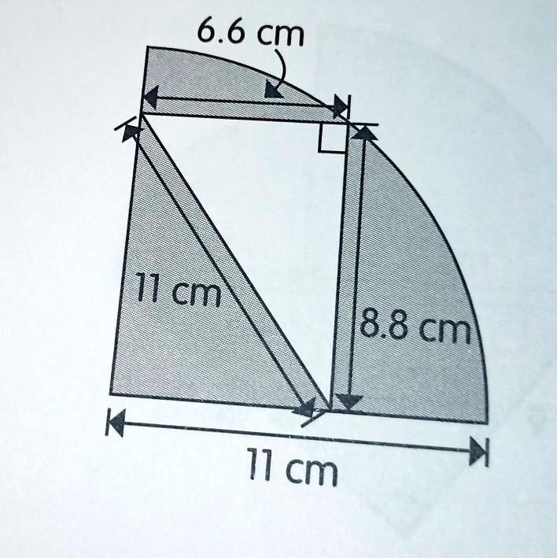
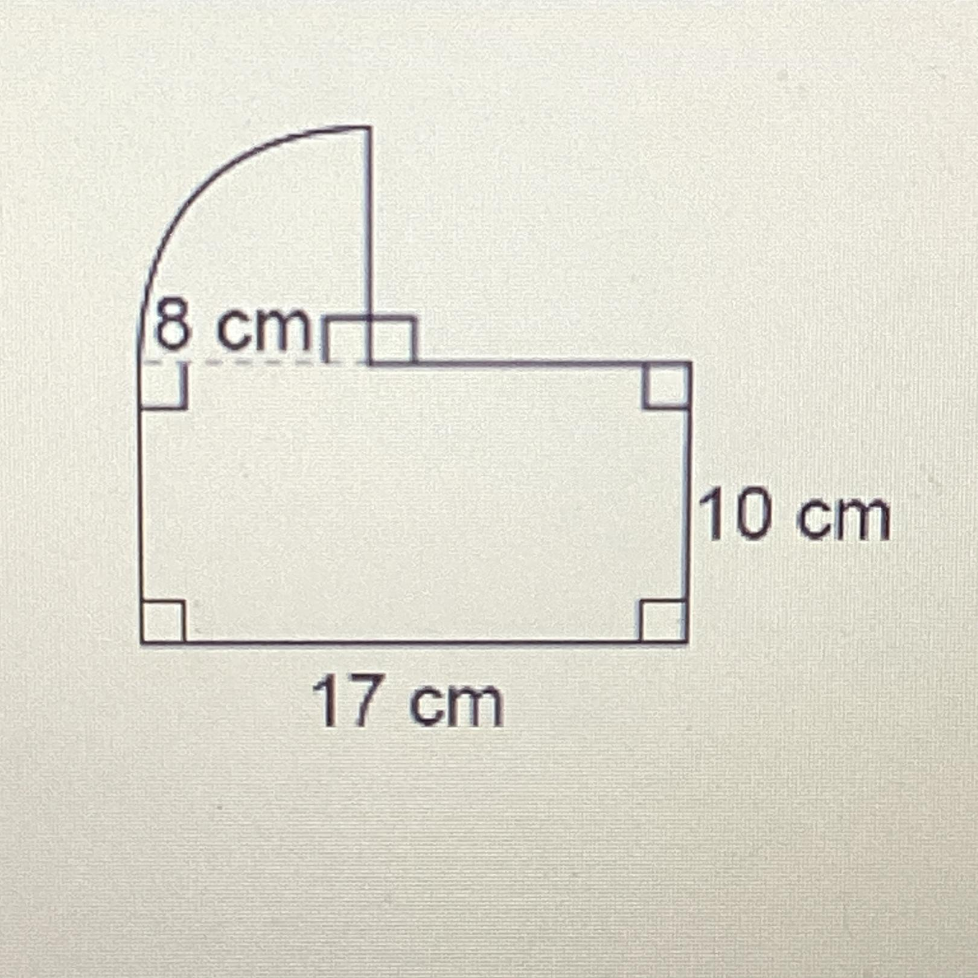
A polygonal region is combined with one or more quarter-circle arcs.

3. Polygon + Circular Segment
# Source: AI Source: Provided by: [Data Path: Persons Table -> ID Column: 1, Name_En Column: Motasem Essam] -> From: [ChatGPT] on [7/25/2026]

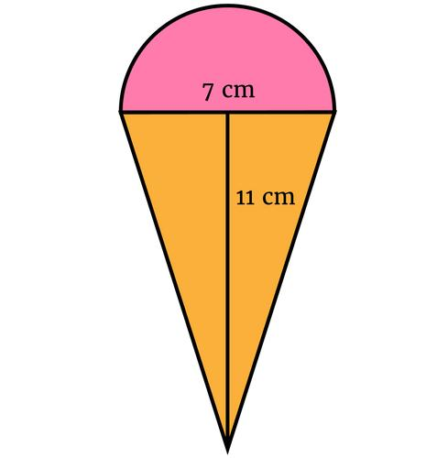
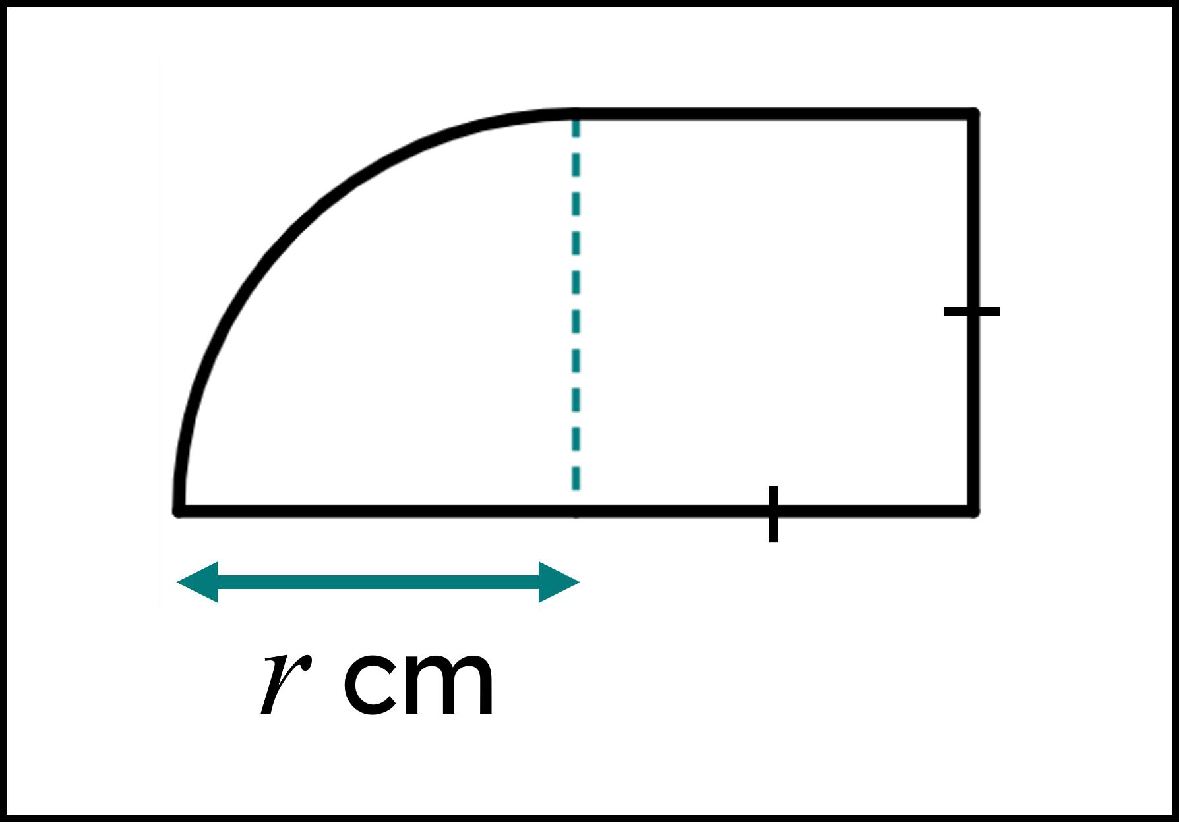
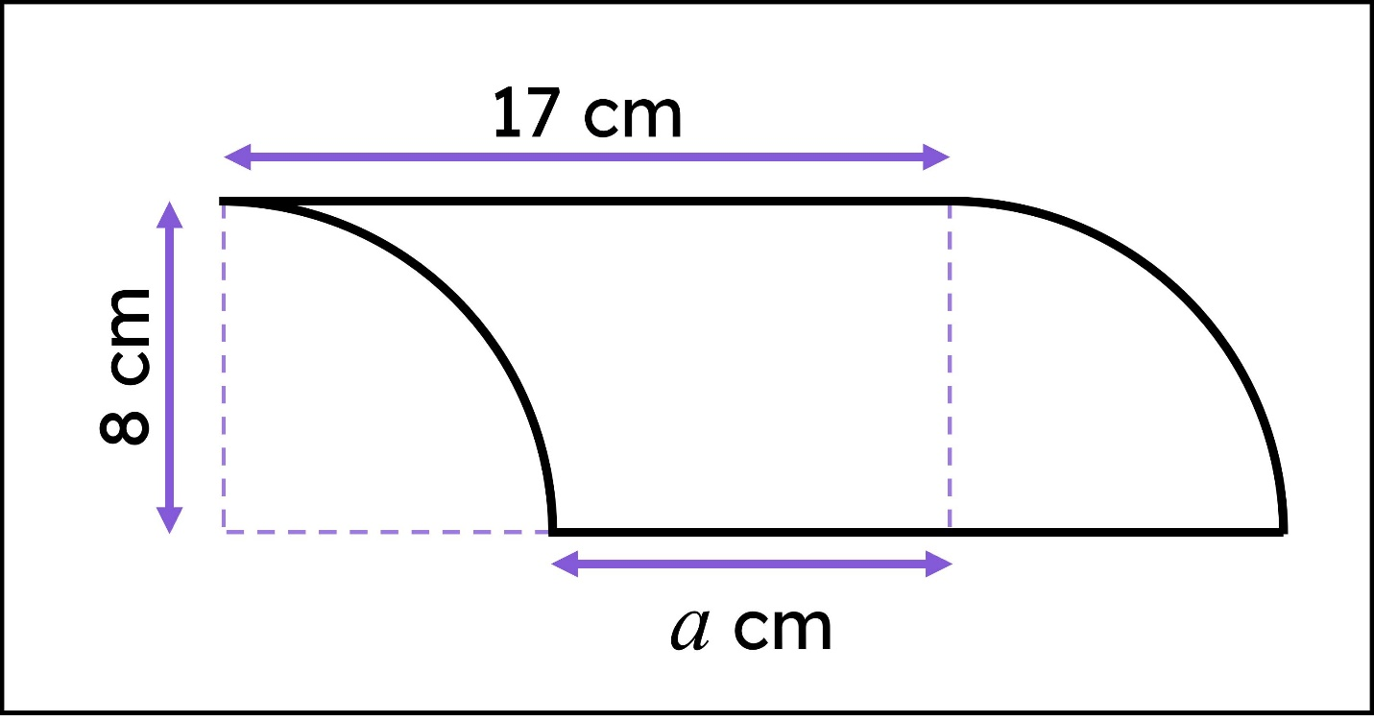
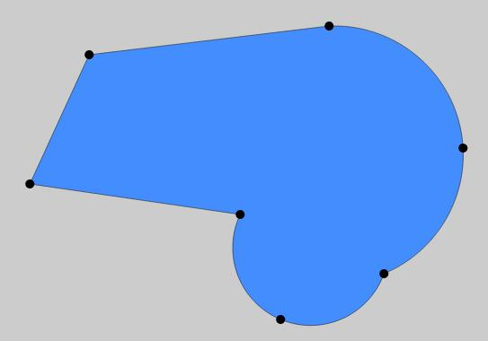
Part of the boundary is a circular arc while the remaining boundary consists of straight segments.

4. Polygon + Multiple Circular Arcs
# Source: AI Source: Provided by: [Data Path: Persons Table -> ID Column: 1, Name_En Column: Motasem Essam] -> From: [ChatGPT] on [7/25/2026]
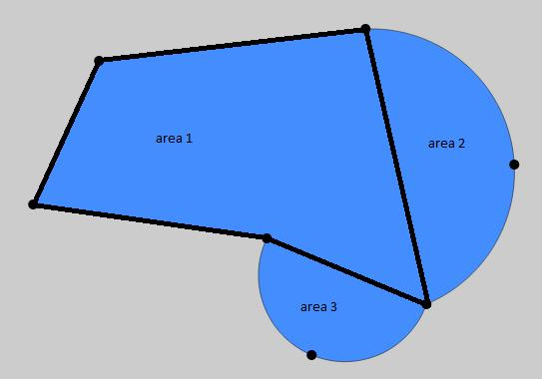
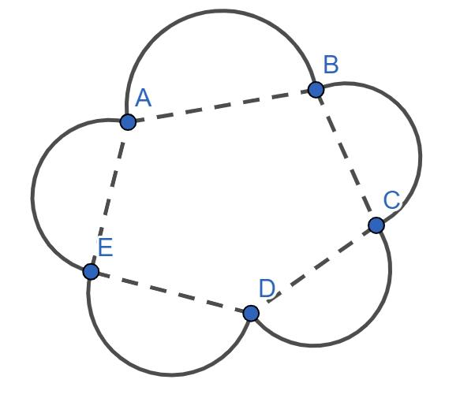
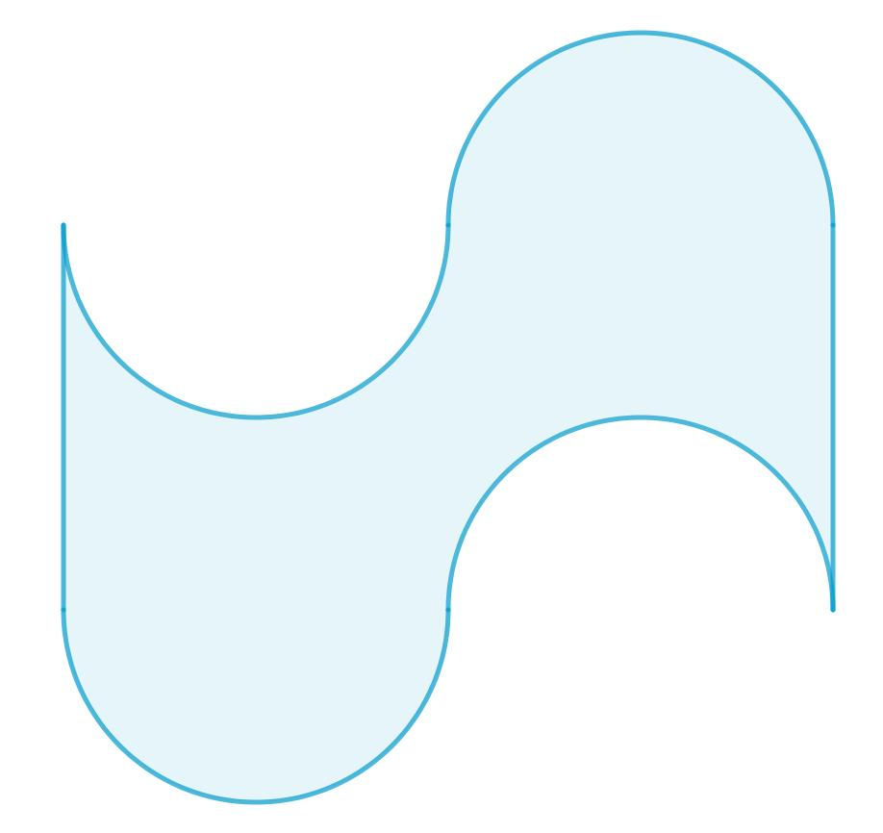
Several circular arcs can be combined with polygonal edges to create a more complex irregular shape.

5. Polygon + Full Circle Component
# Source: AI Source: Provided by: [Data Path: Persons Table -> ID Column: 1, Name_En Column: Motasem Essam] -> From: [ChatGPT] on [7/25/2026]
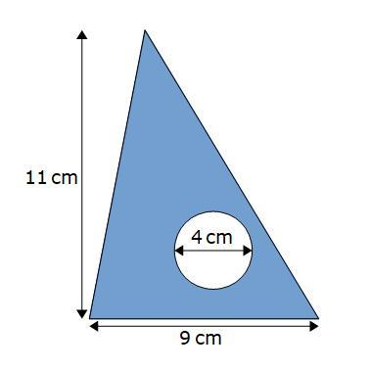
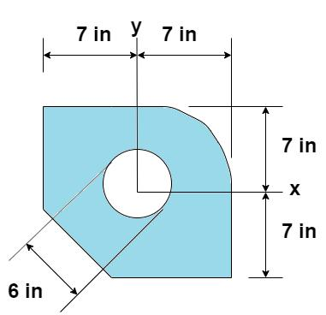

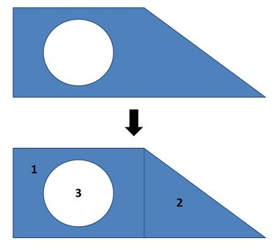
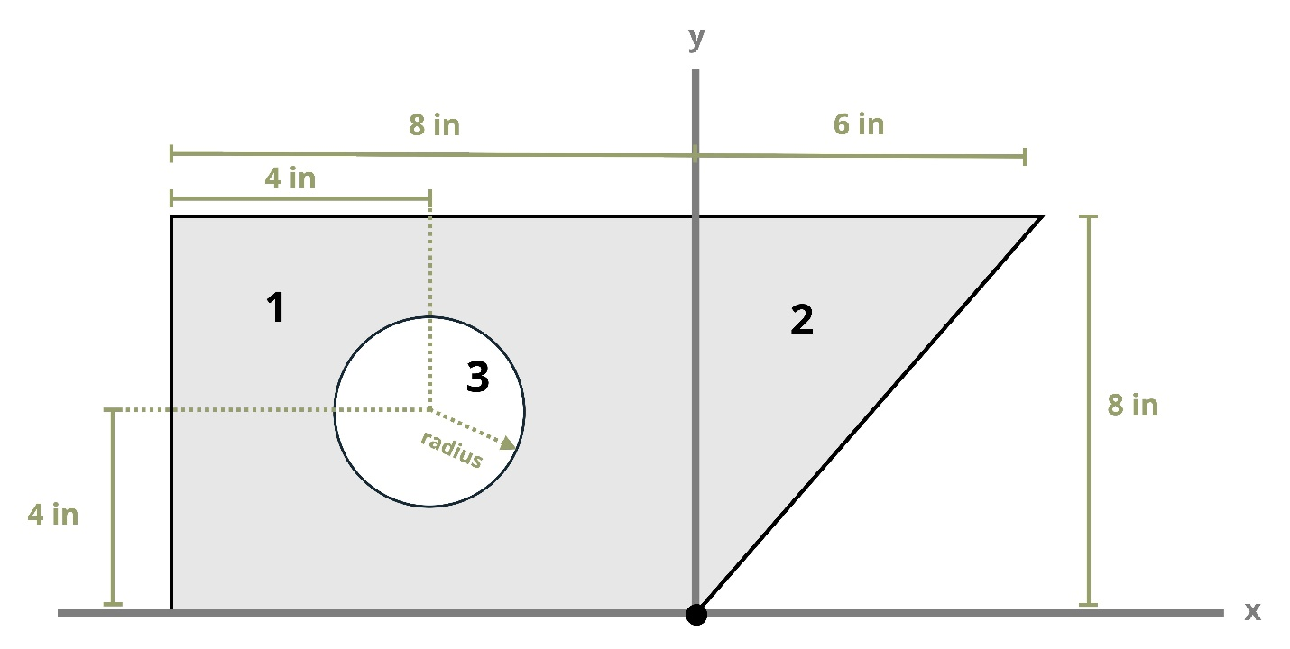
A circular component can be incorporated into a polygonal shape, including cases where the circle forms an internal hole.

Boundary Classification
# Source: AI Source: Provided by: [Data Path: Persons Table -> ID Column: 1, Name_En Column: Motasem Essam] -> From: [ChatGPT] on [7/25/2026]
The boundary of a polygon–circular mixed shape contains both straight and curved portions:
$$\boxed{\text{Boundary}=\text{Straight Segments}+\text{Circular Arcs}}$$
Therefore, it can also be classified as a mixed boundary.
For example:
$$\boxed{\text{Mixed Boundary}=\text{Straight Boundary}+\text{Curved Boundary}}$$

Area
# Source: AI Source: Provided by: [Data Path: Persons Table -> ID Column: 1, Name_En Column: Motasem Essam] -> From: [ChatGPT] on [7/25/2026]
One of the main advantages of decomposing a polygon–circular mixed shape is that its area can often be calculated by separating it into simpler components.
For example:
$$A_{\text{total}}=A_{\text{polygon}}+A_{\text{semicircle}}$$
Since:
$$A_{\text{semicircle}}=\frac{1}{2}πr^{2}$$
we obtain:
$$\boxed{A_{\text{total}}=A_{\text{polygon}}+\frac{1}{2}πr^{2}}$$
If a circular part is removed:
$$\boxed{A_{\text{total}}=A_{\text{polygon}}-A_{\text{circular part}}}$$

Perimeter
# Source: AI Source: Provided by: [Data Path: Persons Table -> ID Column: 1, Name_En Column: Motasem Essam] -> From: [ChatGPT] on [7/25/2026]
The perimeter is calculated by combining the lengths of the straight and curved boundary portions:
$$\boxed{P=\sum{L_{\text{straight}}}+\sum{L_{\text{arc}}}}$$
For a circular arc:
$$L_{\text{arc}}=rθ$$
when (\theta) is measured in radians.
For a semicircle:
$$L_{\text{arc}}=πr$$
So a composite perimeter might be:
$$P=L_{1}+L_{2}+L_{3}+πr$$

Polygon–Circular vs. Polygonal Shapes
# Source: AI Source: Provided by: [Data Path: Persons Table -> ID Column: 1, Name_En Column: Motasem Essam] -> From: [ChatGPT] on [7/25/2026]
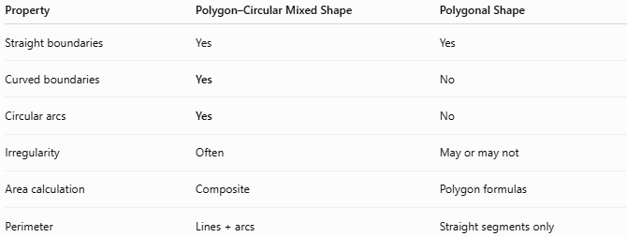
Property | Polygon–Circular Mixed Shape | Polygonal Shape
Straight boundaries | Yes | Yes
Curved boundaries | Yes | No
Circular arcs | Yes | No
Irregularity | Often | May or may not
Area calculation | Composite | Polygon formulas
Perimeter | Lines + arcs | Straight segments only

Polygon–Circular vs. Curved Shapes
# Source: AI Source: Provided by: [Data Path: Persons Table -> ID Column: 1, Name_En Column: Motasem Essam] -> From: [ChatGPT] on [7/25/2026]
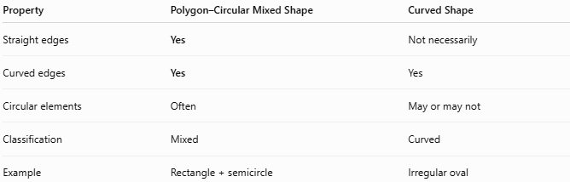
Property | Polygon–Circular Mixed Shape | Curved Shape
Straight edges | Yes | Not necessarily
Curved edges | Yes | Yes
Circular elements | Often | May or may not
Classification | Mixed | Curved
Example | Rectangle + semicircle | Irregular oval

Key Points
# Source: AI Source: Provided by: [Data Path: Persons Table -> ID Column: 1, Name_En Column: Motasem Essam] -> From: [ChatGPT] on [7/25/2026]
A Polygon–Circular Mixed Shape combines:
$$\boxed{\text{Straight Polygonal Parts}+\text{Circular/Arc Parts}}$$
It therefore has a mixed boundary consisting of straight and curved sections.
Its:
- Area can usually be found by adding or subtracting component areas.
- Perimeter is found by adding straight-segment lengths and circular-arc lengths.
- Shape classification depends on both its polygonal and circular components.

Conclusion
# Source: AI Source: Provided by: [Data Path: Persons Table -> ID Column: 1, Name_En Column: Motasem Essam] -> From: [ChatGPT] on [7/25/2026]
Polygon–Circular Mixed Shapes are irregular composite shapes that combine polygonal elements with circular elements or circular arcs. They are particularly useful for describing real-world objects and designs that cannot be represented by a single basic geometric shape. Examples include rectangles with semicircular ends, polygons with circular segments, and shapes containing multiple circular arcs. Their measurements are normally determined by decomposing the shape into simpler polygonal and circular components.

